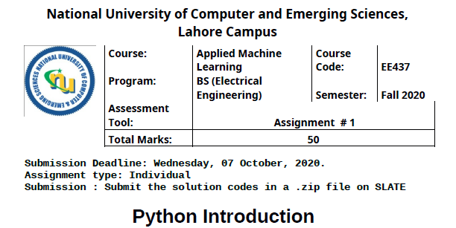

FAROOQ AHMAD
17L 4407
BEE 7B

- Write a Python program to count and display the vowels of a given text.

#question1
string = "My Name is Farooq Ahmad"
vowels = ['a','e','i','o','u']
count = 0
for alphabet in string:
if alphabet.lower() in vowels:
count += 1
print(f'vowels in my string are {count}')

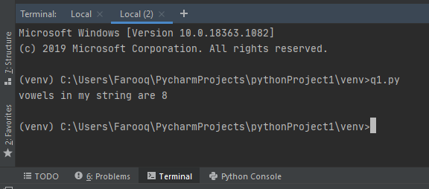
- Write a Python program to remove duplicates from a list of lists.

Sample list : [[33, 120], [40], [30, 56, 25], [33, 120], [33], [40]]
New List : [[33, 120], [30, 56, 25], [33], [40]]

#question2
lists = [[33, 120], [40], [30, 56, 25], [33, 120], [33], [40]]
newlist = []
for list in lists:
if list not in newlist:
newlist.append(list)
print(f'the original list is {lists} \nthe new updated list is {newlist}')

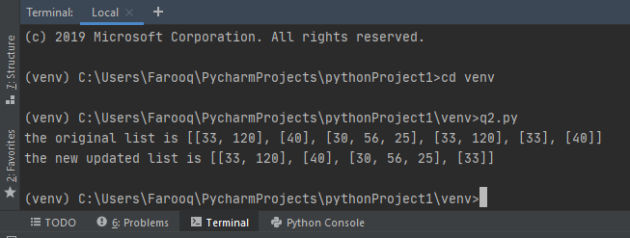

- Write a Python program to remove an empty tuple(s) from a list of tuples.

Sample data: [(), (), ('',), ('a', 'b'), ('a', 'b', 'c'), ('d')]
Expected output: [('',), ('a', 'b'), ('a', 'b', 'c'), 'd']

#question3
mytuple = [(), (), ('',), ('a', 'b'), ('a', 'b', 'c'), ('d')]
tuples = [value for value in mytuple if value]
print(f'the original tuple list is {mytuple} \nthe new updated tuple list is {tuples}')

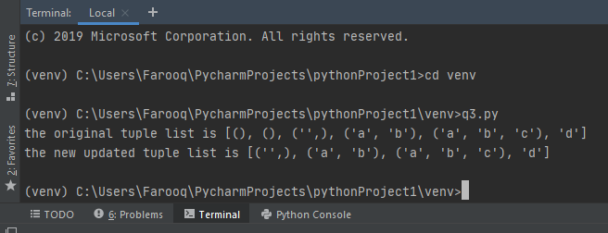

- Write a Python program to combine two dictionary adding values for common keys.

dictonary1 = {'a': 100, 'b': 200, 'c':300}
dictionary2 = {'a': 300, 'b': 200, 'd':400}
Sample output: Counter({'a': 400, 'b': 400, 'd': 400, 'c': 300})
#question4
from collections import Counter
dictonary1 = {'a': 100, 'b': 200, 'c':300}
dictionary2 = {'a': 300, 'b': 200, 'd':400}
dictionary = Counter(dictonary1) + Counter(dictionary2)
print(f'the Counter dictionary is {dictionary}')

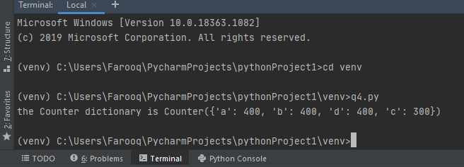

- In section 4 of Python tutorial, data munging process is demonstrated. Run and analyze all the python commands on same train.csv (provided with assignment) and match histogram and distribution graphs with your output. You have seen that the missing values in loan amount column are replaced by mean values. Your task is to explore three other ways of your choice of replacing the missing values. All values should be replaced by single value (i.e you can take standard deviation and replace missing values by it). For all three methods, fill self_employed column value with YES and NO. So there will be total 6 models. All other values in missing columns will be replaced by mean value or most occurrences (in case of Boolean).
Analyze and comment on each output. What do you think which model is more practical in the above scenario and why? Briefly explain.

import pandas
import numpy as np
import matplotlib.pyplot as plt
df=pandas.read_csv('./TrainFile.csv')
y=df.apply(lambda x: sum(x.isnull()),axis=0)
print(y)
df['LoanAmount'].fillna(df['LoanAmount'].mean(), inplace=True)
z=df.apply(lambda x: sum(x.isnull()),axis=0)
print(z)
counts=df['Gender'].value_counts()
print(counts)
print(counts.idxmax())
df['Gender'].fillna(counts.idxmax(),inplace=True)
z=df.apply(lambda x: sum(x.isnull()),axis=0)
print(z)

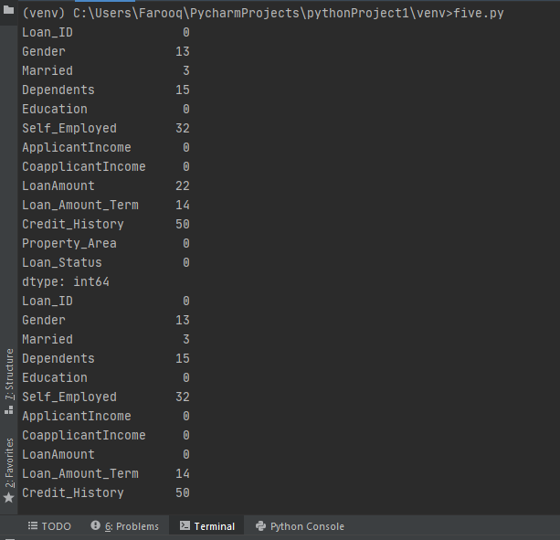

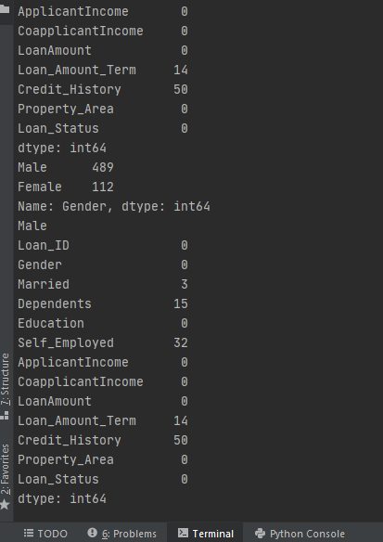

Ways of replacing the missing values includes
- Mean
- Median
- Mode
- Most recent
- Most frequent
- Leave unchanged

- Extreme values of loan amount and applicant income are normalized in section 4 of python tutorial by taking logs of original value. Think about some other way to normalize both these columns (applicant income and loan amount)? Compare your histogram with the provided example. How your method is more practical?
Briefly explain how will you impute the missing values for Gender, Married, Dependents, Loan_Amount_Term, Credit_History keeping in mind the practical scenario.

import pandas
import numpy as np
import matplotlib.pyplot as plt
df=pandas.read_csv('./TrainFile.csv')
y=df.apply(lambda x: sum(x.isnull()),axis=0)
print(y)
df['LoanAmount'].fillna(df['LoanAmount'].mean(), inplace=True)
z=df.apply(lambda x: sum(x.isnull()),axis=0)
print(z)
counts=df['Gender'].value_counts()
print(counts)
print(counts.idxmax())
df['Gender'].fillna(counts.idxmax(),inplace=True)
z=df.apply(lambda x: sum(x.isnull()),axis=0)
print(z)
df['LoanAmount_log'] = np.log(df['LoanAmount'])
df['LoanAmount_log'].hist(bins=20)
plt.show()
df['TotalIncome'] = df['ApplicantIncome'] + df['CoapplicantIncome']
df['TotalIncome_log'] = np.log(df['TotalIncome'])
df['TotalIncome_log'].hist(bins=20)
plt.show()

